Bible Book Activities
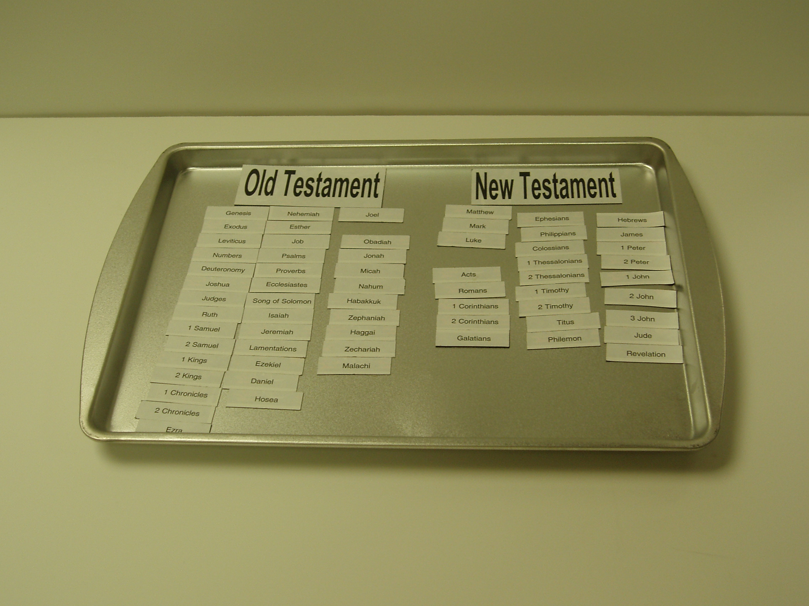

Magnetic Books: Attach magnet strips to the books of the Bible. Place in random order on a cookie sheet. Challenge the children to arrange the books in the correct order.

Bible Bingo: Make Bible Bingo Cards designating the sections of the board with Old Testament Divisions. Place books within the sections in random order. Call out books without saying the division. The first player to have 5 in a row wins.

Clip It: Attach the names of the books of the Bible to clothespins. Make a game board with the divisions listed around the edge. Mark a space to indicate how many books are in each division. Challenge the children to clip the books to the correct space on the board.

Bible Library: Make books by covering small, empty boxes. Print the names of each Bible book on the spines. Challenge the children to arrange the books in the correct order.

Stack ‘em Up!: Print the names of Bible books on the rims of foam cups. Challenge the children to stack the cups so that the books are in the correct order.

Bible Book Review: Write each book of the Bible on a card. Create a game spinner from the lid of a plastic container. Divide the lid into 4 equal wedges. Write one of these instructions in each section: “Name the book before,” “Name the book after,” “Pronounce the book,” and “Find the Book.” Use a brad to fasten a spinner to the center of the lid. Challenge the children to draw a book then spin and follow the instructions where the spinner lands.

Bible Books Review Beads: String alphabet beads representing the initial letter of each book of the Bible, placing a blank bead between each division. Children may use the beads to review the books of the Bible.

Bible Book Mat: Print these letters & numbers in random order on a plastic sheet: G,E,L,N,D,J,R,S,1,2,3,K,C,P,I,H,O,Z,M,A,T. Challenge the children to jump from letter to letter naming the books of the Bible in the correct order.

